CAPHY: AN AI-BASED INTELLIGENT SECURITY SYSTEM
WITH TWO-FACTOR MOTION VALIDATION AND
MONITORING PROTOCOLS

A Thesis Presented to the Faculty of the Computer Science
Taguig City University, General Santos Avenue
Central Bicutan, Taguig City

In Partial Fulfillment of the Requirements for the Degree of
Bachelor of Science in Computer Science

By

Khemberly D. Alao
King Leonard V. Kidsolan
Mark Alphy R. Miasis
Aedrean Marl I. Nudalo

May 2026

CHAPTER I

INTRODUCTION

Background of the Study
The rise of Internet of Things (IoT) technology has turned smart home security from a luxury into a standard need. However, most modern security systems rely heavily on centralized cloud architectures. While this setup works well in countries with strong internet infrastructure, a cloud-first approach creates major problems in developing nations like the Philippines. Issues such as high network latency, frequent power outages, data privacy risks, and the high cost of proprietary hardware make these systems difficult to use for the average Filipino household. Additionally, traditional security cameras often cause “alert fatigue,” constantly sending notifications for harmless background movements, which eventually makes users ignore actual threats.

Rationale
The name CAPHY itself began informally during early planning, as a shorthand blend of “Capture” — the system’s core function of capturing motion and images — and “Alphy,” a nod to team member Mark Alphy R. Miasis. What started as a casual working title stuck with the group and was carried forward as the project’s formal name, eventually standing for the system now described throughout this study: an AI-Based Intelligent Security System with Two-Factor Motion Validation and Monitoring Protocols.
This study argues that by repurposing such devices into a Repurposed Hardware Architecture and performing the primary artificial-intelligence processing locally, homes can achieve dependable security monitoring while keeping the overall cost low.
CAPHY performs its artificial-intelligence processing — motion detection and object verification — locally on the host laptop, so the system continues to detect and respond to threats even when the internet is down. Connectivity is then used adaptively rather than constantly: when the internet is available, verified alerts and captured media are delivered as push notifications through the dedicated CAPHY App and synced to cloud storage; when the connection is offline or the signal is weak, the same data is stored locally and compressed to conserve space until connectivity returns. Simply put, the laptop does the guarding and the internet does the messaging: detection, recording, the siren, and core voice commands run on the laptop with or without internet, while phone alerts and cloud backup resume automatically once a connection is available. In this way a household gains resilient security without paying recurring subscription fees or depending on a constant, high-speed internet connection.

Project Context
This project introduces CAPHY: An AI-Based Intelligent Security System, built to operate within the connectivity and power constraints common to Philippine households. CAPHY performs its core artificial-intelligence tasks — video motion analysis and object verification — locally on a repurposed host laptop, allowing threat detection to continue during internet or power interruptions. The system is neither fully cloud-dependent nor fully offline; instead, it adapts to the connectivity that is available. When the internet is present, verified alerts and captured media are transmitted to the homeowner through the dedicated CAPHY App and synced to cloud storage. When the network is offline or the signal is weak, the same data is retained in compressed form in local storage until a connection is restored. Live camera viewing, meanwhile, is served only over the home’s local Wi-Fi network, keeping continuous video off the public internet. In effect, the host laptop acts as an autonomous local server that uses internet bandwidth opportunistically rather than continuously.

Purpose and Description

The main goal of this study is to build a smart, resilient, and affordable home-security system using a Repurposed Hardware Architecture. CAPHY uses a Two-Factor Motion Validation protocol that combines OpenCV to detect initial movement (Factor 1) and a YOLO model to confirm whether that movement is an actual person or object (Factor 2). By requiring both factors before raising an alarm, the system filters out false alarms, conserves processing power, and reduces alert fatigue — the tendency for users to stop paying attention to notifications when too many of them turn out to be false.

CAPHY features a Proximity-Based Alert system delivered through the CAPHY App, the system’s own dedicated mobile application, which receives push notifications through Firebase Cloud Messaging. The system classifies detections through a Three-Tier response: Tier 1 sends a snapshot and a notification; Tier 2 adds a short video clip on top of the snapshot and notification; and Tier 3 adds the audible siren on top of the snapshot, video, and notification. When the system is placed in Armed mode, every tier escalates directly to the full Tier 3 response — siren, recording, and high-priority alert — so no detection is under-reported while the household is actively secured. To keep the tier stable in normal monitoring, CAPHY smooths the estimated distance over successive frames and applies hysteresis at each tier boundary, so a person standing near a threshold does not cause the tier — and the siren — to flicker.
The system also includes a Tagalog-capable voice engine with a back-and-forth (multi-turn) confirmation feature, allowing users to control the system by voice when the required device configuration is available. This voice control is designed to support a limited set of predefined security commands locally, while broader functionality may depend on internet availability and compatible system configuration. It is therefore presented as a supported but bounded feature rather than a fully autonomous PC-side voice system.

To keep the system usable at night, CAPHY applies a software-based night-vision mode that brightens and enhances the camera feed in low light, allowing detection to continue in dim conditions without additional infrared hardware. For safe operation, the system starts in a disarmed state and applies a brief arming grace period, so that arming the system — or launching it while the user is still in front of the camera — does not immediately trigger the siren. A short camera warm-up period on startup likewise prevents false alerts from firing before the feed has stabilized.

Objectives of the Study
This study aims to improve the accessibility and reliability of smart home security by developing CAPHY, a localized AI-based security system that combines two-factor motion validation with adaptive monitoring protocols suited to variable power and internet conditions.

Specific Objectives
- To implement a Repurposed Hardware Architecture in which an older or unused laptop serves as the local security server — performing AI processing on-device and using its built-in battery as backup power — so the system keeps running during power and internet interruptions, syncing to cloud storage when connectivity is available and storing data locally (compressed) when it is not.
- To develop a Two-Factor Motion Validation protocol using OpenCV and YOLO to reduce false threats and minimize alert fatigue.
- To integrate a Monitoring Protocol through the CAPHY App that adjusts data transmission, such as images versus video, based on the 3-Tier Threat Level logic and the current network conditions.
- To construct a Tagalog-capable Voice Engine with a multi-turn confirmation system that supports a defined set of security commands locally, helping prevent accidental triggers from background noise.
- To test and evaluate CAPHY: An AI-Based Intelligent Security System with Two-Factor Motion Validation and Monitoring Protocols using the ISO/IEC 25010 software-quality standard in terms of the following: Functional Suitability, Performance Efficiency, Compatibility, Usability, Reliability, Security, Maintainability, and Portability.

Conceptual Framework

CAPHY: AN AI-BASED INTELLIGENT SECURITY SYSTEM WITH TWO-FACTOR MOTION VALIDATION AND MONITORING PROTOCOLS

To enhance the accessibility and reliability of smart home security through a localized, AI-based system that combines two-factor motion validation with adaptive monitoring protocols suited to variable power and internet conditions
Knowledge Requirements

Hardware Requirements:
- Standard host laptop or desktop (repurposed as the server)
- Built-in laptop camera, USB webcam, or phone camera (via IP-camera streaming); the system supports up to two cameras at a resolution of 640 × 480

Software Requirements:
- Python with Flask (local server, REST API, and MJPEG live stream)
- YOLOv8 models; OpenCV (with CLAHE low-light enhancement)
- Vosk offline speech recognition
- CAPHY App (Flutter mobile application) with Firebase Cloud Messaging
- SQLite local database; Windows OS

Live System Data:
- Real-time video feeds
- Tagalog/English voice commands
- Laptop battery status
- Current network status (online, offline, or low-signal)

Methodology

Iterative System Development:
- Planning
- Coding
- Testing

AI Integration:
- OpenCV pixel-shift detection with CLAHE night-vision enhancement
- YOLO object classification and proximity-tier estimation, stabilized with distance smoothing and hysteresis
- Local (offline-capable) voice processing

Adaptive Storage & Alerting:
- Firebase push alerts and cloud sync when online; compressed local storage when offline or on a weak signal

System Evaluation using ISO/IEC 25010:
- Functional Suitability, Performance Efficiency, Compatibility, Usability, Reliability, and Security, Maintainability, and Portability.
PROCESS
OUTPUT
INPUT

FEEDBACK

Figure 1. Conceptual Paradigm
The conceptual framework of the study, as shown in Figure 1, utilizes the Input–Process–Output (IPO) model to illustrate the development and operational flow of the CAPHY system. A feedback loop is integrated to ensure continuous system refinement based on the results of the software evaluation.
The Input consists of the essential knowledge, hardware, software, and live data required to initiate the project. The Hardware Requirements include a standard laptop or desktop acting as the repurposed server and two independently controlled cameras, which may be USB webcams, Bluetooth-connected cameras, or smartphone cameras streamed through a companion app. Each camera supports a resolution of 960 × 480 and can be opened or closed independently. The Software Requirements include Python with Flask for the local server, YOLOv8 and OpenCV for AI and computer vision, Vosk for offline speech recognition, SQLite for local event logging, and the Flutter-based CAPHY App with Firebase Cloud Messaging for remote alerts. The system also uses Live System Data, such as real-time video feeds, Tagalog/English voice commands, battery status, and network status, to determine whether data should be synchronized to the cloud or stored locally.
The Process encompasses the development methodology and the core technical operations. The Iterative System Development stage involves a cycle of planning, coding, and testing. This is followed by the AI Integration, which represents the primary technical innovation of the study: using OpenCV for pixel-shift detection and YOLO for object classification to form the Two-Factor Motion Validation protocol, supported by CLAHE-based low-light enhancement and proximity-tier estimation with distance smoothing and hysteresis. This stage also includes local, offline-capable voice processing for command execution. In parallel, an Adaptive Storage and Alerting layer routes captured media and alerts to cloud storage and Firebase push notifications when the connection is available and to compressed local storage when it is not, with a background retry process ensuring queued items are correctly marked as synced once uploaded. Finally, the system undergoes a rigorous evaluation using the ISO/IEC 25010 standard, specifically testing for Functional Suitability, Performance Efficiency, Usability, Reliability, and Security.
The Output of the study is the completed CAPHY system, a resilient, privacy-conscious solution that keeps artificial-intelligence processing on the local device and delivers intelligent remote alerts through its own dedicated app. This is supported by a Feedback loop, where evaluation data from IT experts and end-users is used to refine the system’s logic and inputs, ensuring the final architecture meets all professional standards and user needs.

Scope
This study focuses on the development of CAPHY, a localized AI-based security system that uses two-factor motion validation and adaptive remote-monitoring protocols. While the system’s Repurposed Hardware Architecture is ultimately designed to serve as an affordable, resilient security solution for average Filipino households, the actual deployment, testing, and evaluation of the prototype will be conducted in controlled environments — specifically, a university laboratory setting, complemented by testing in a house setting to simulate residential conditions, including nighttime operation and scenarios with lights switched on and off, to validate its technical performance.
The project implements features for accurate threat detection, offline voice control, and adaptive alert management. It uses a Repurposed Hardware Architecture, allowing the host laptop’s built-in battery to support operation during short power interruptions. A Tagalog-capable Voice Engine enables real-time offline control using core voice commands, while the CAPHY App with Firebase Cloud Messaging delivers verified security alerts to authorized users under varying network conditions. Evidence is synchronized to cloud storage when online and stored locally in compressed form when offline or on a weak connection. The system also includes CLAHE-based night vision for improved low-light visibility and a Tier-3 audible siren that remains active until the alert is acknowledged through the app, dashboard, or voice command. To reduce false alarms, CAPHY starts disarmed, applies a short arming grace period, suppresses the siren during this period, and uses a brief camera warm-up before detection begins. For the initial laboratory phase, camera input will depend on equipment availability: the system supports a wired (USB) webcam, a Bluetooth-connected camera, or a smartphone camera streamed over the local network via a companion app, whichever is accessible at the time of testing.

Limitations
The system is limited to localized security-management features within the designated residential testing sites; it excludes the monitoring of other locations or facilities beyond these controlled environments. The system supports two simultaneous camera feeds, each independently controlled and opened or closed on its own. Live remote viewing operates over the local Wi-Fi network only and is subject to minor streaming delay rather than being perfectly instantaneous. Software-based night vision improves visibility in low light but does not provide true vision in total darkness without added infrared hardware. The 3-Tier Threat Level uses distance thresholds of greater than 4.5 meters for Tier 1, between 2.5 and 4.5 meters for Tier 2, and less than 2.5 meters for Tier 3; because the distance is estimated from the height of the detection bounding box rather than a dedicated depth sensor, these thresholds remain subject to calibration during testing. Lastly, the voice engine assistance and system control are strictly limited to pre-defined security commands and do not support general conversational interactions.

Significance of the Study
This study is focused on CAPHY, a localized AI-based security system utilizing two-factor motion validation and adaptive remote monitoring, prototyped at Taguig City University. The significance of this study is to ensure that residential security is accessible, resilient, and privacy-conscious, allowing homeowners and researchers to deliver the best out of modern technology despite infrastructure limitations. With this, there would be a significant improvement in domestic safety performance; when households are secured reliably, it creates a positive impact on the community and the nation at large by reducing property-related crimes and enhancing public peace of mind. This research holds significance for both educational institutions and policymakers, as it facilitates the development of appropriate policies regarding hardware sustainability and the formulation of effective solutions to address challenges arising from the “digital divide” and inconsistent internet infrastructure.
For Filipino Homeowners, this research offers an affordable, low-cost-to-run alternative to commercial systems. Because AI processing runs locally and the system falls back to battery power and local storage, it functions reliably despite local power interruptions (brownouts) or slow internet speeds, providing a user-friendly platform for protecting their families and properties.
For the Cybersecurity and Data Privacy Sector, this study demonstrates how a hybrid local–cloud design can strengthen residential data privacy. Because video is analyzed on the local device, live viewing stays on the local network, and alerts are routed through the system’s own dedicated CAPHY App rather than a third-party messaging platform, exposure of private footage is minimized. When cloud storage is used, it is the system’s own configured storage under the owner’s control, consistent with responsible handling of personal data under the Data Privacy Act (RA 10173).
For Future Researchers, this study provides a foundational architecture for further work in resilient smart-home security, including offline-capable Tagalog voice control, self-hosted alert delivery through a dedicated app, and the sustainable repurposing of outdated hardware.
For the Academic Institution, this project will serve as a foundational testing ground. By allowing the researchers to simulate a residential deployment within a university laboratory setting, it streamlines the practical application of AI and computer vision in a real-world setting, creating opportunities for technical learning and future collaboration among student research initiatives.

Operational and Technical Definition of Terms
Alert Fatigue – Technically, the psychological phenomenon in which a user becomes desensitized to frequent security notifications. Operationally, CAPHY reduces it by using Two-Factor Motion Validation so that only verified threats trigger a notification.
Armed Mode – Operationally, a heightened-security state in which any confirmed detection, regardless of tier, is escalated directly to a full Tier 3 response — siren, video recording, and high-priority alert — removing the graduated response used during normal monitoring.
Arming Grace Period – Operationally, a short interval (eight seconds by default) after the system is armed during which alerts and the siren are suppressed, so arming the system — or launching it while the user is still in view of the camera — does not immediately trigger an alarm. CAPHY also starts in a disarmed state for the same reason.
CAPHY – The name of the proposed system: an AI-Based Intelligent Security System with two-factor motion validation and monitoring protocols. Operationally, it is the central software hub that manages motion detection, voice commands, storage, and remote alerts.
CAPHY App – Operationally, the system’s own custom-built mobile companion application, developed with Flutter, which receives and displays remote alerts, threat snapshots, and video clips from the host laptop through Firebase Cloud Messaging, without relying on a third-party messaging platform.
CLAHE (Contrast Limited Adaptive Histogram Equalization) – Technically, an image-processing technique that improves local contrast in dark images. Operationally, it is the software method behind CAPHY’s night-vision mode, brightening the camera feed so detection remains usable in low light.
Camera Warm-Up Period – Operationally, a short interval after a camera is opened or the system is launched during which detection results are held back, preventing false alerts caused by the feed stabilizing (auto-exposure and auto-focus settling).
Edge (Local) AI Processing – Technically, the methodology of running AI algorithms on the local hardware device rather than on a remote cloud server. Operationally, CAPHY performs motion detection and object verification on the host laptop, so detection works even without internet; this is combined with cloud storage when a connection is available.
Firebase Cloud Messaging (FCM) – Technically, a cross-platform push-notification service. Operationally, it is the delivery channel that carries CAPHY’s verified alerts from the host laptop to the CAPHY App on the owner’s phone whenever an internet connection is available.
Hybrid Local–Cloud Architecture – Operationally, CAPHY’s overall design in which AI processing is performed locally while storage and alert delivery adapt to connectivity — syncing to the cloud when the internet is available and saving to compressed local storage when offline or on a weak signal. The cloud layer is implemented using Firebase, specifically Firestore for event data, Firebase Storage for media, Firebase Authentication for user accounts, and Firebase Cloud Messaging for alerts.
MJPEG Live Stream – Technically, a video stream composed of sequential JPEG frames served over HTTP. Operationally, it is how CAPHY provides live camera viewing to devices on the same local Wi-Fi network, keeping continuous video off the public internet.
Multi-Turn Dialogue – Operationally, the voice engine’s confirmation protocol, which requires a back-and-forth interaction between the system and the user to prevent accidental triggers from background noise.
Night Vision (Low-Light Enhancement) – Operationally, a software-based mode, implemented with CLAHE, that brightens and enhances the camera feed so detection remains usable in dim conditions; it improves low-light visibility but does not provide vision in total darkness without added infrared hardware.
OpenCV (Open-Source Computer Vision Library) – Technically, an open-source library used for real-time computer vision. Operationally, it is the “First Factor” of motion detection, used to identify pixel-shifts before activating heavier AI models.
Repurposed Hardware Architecture – Operationally, the system design of using older or depreciated laptops to serve as the local security server, utilizing their built-in batteries as an Uninterruptible Power Supply (UPS) during power outages.
Tagalog-Capable Voice Engine – Operationally, the voice-control component that recognizes a defined set of predefined security commands in Tagalog/English. It works offline for these core commands and can operate with broader capability when an internet connection is available; it is not a fully offline or general conversational engine.
3-Tier Threat Level – Operationally, the proximity-based logic that classifies a detected person by distance — estimated from the height of the detection bounding box — and sets the system’s response. A person farther than 4.5 meters is Tier 1 (Far), which triggers a snapshot and a notification; between 2.5 and 4.5 meters is Tier 2 (Medium), which adds a short video clip; and closer than 2.5 meters is Tier 3 (Close), which adds the audible siren on top of the snapshot, video, and notification. Under Armed Mode, every tier escalates directly to the full Tier 3 response. To keep the classification steady during normal monitoring, the estimated distance is smoothed across frames and a hysteresis margin is applied at each boundary. (Distance thresholds are calibratable during testing.)
Two-Factor Motion Validation – Operationally, a dual-layer detection process in which OpenCV first detects movement (Factor 1) and the YOLO model then confirms whether the movement is a specific object or person (Factor 2) before an alert is sent.
YOLO (You Only Look Once) – Technically, a state-of-the-art, real-time object-detection system. Operationally, it is the “Second Factor,” used to classify detected motion into specific categories such as “person.”

CHAPTER II

REVIEW OF RELATED LITERATURE AND STUDIES
This chapter presents a review of related literature and studies that provide the conceptual and technical foundation for the CAPHY system. The review is organized thematically around the core problems that CAPHY addresses: localized processing and data privacy, hardware sustainability and lightweight motion validation, adaptive alerting under unreliable networks, offline-capable voice interaction, user-centered mitigation of alert fatigue, and the economic viability of repurposed consumer hardware. Together, these themes situate CAPHY within existing research and clarify the gap it is designed to fill for the average Filipino household.

Localized Processing and Data Privacy
A growing body of work supports the shift of artificial-intelligence workloads from centralized cloud servers toward the network edge. IBM (2024) explains that edge AI processes data on or near the device where it is generated, which reduces latency, lowers the volume of data that must be transmitted, and keeps sensitive information on the local device, thereby making it easier to comply with privacy regulations. These are precisely the properties CAPHY relies on: motion analysis and object verification are performed on the host laptop so that detection continues even when connectivity is poor, while only verified alerts are transmitted outward.
The privacy motivation for local processing is well documented in the smart-home security literature. Hall et al. (2020) surveyed the security challenges and privacy concerns of smart homes and found that the continuous transmission of household data to third-party servers substantially widens the attack surface. Industry reporting reinforces this: consumer smart-camera products have been found uploading footage to the cloud without clear user consent, and large-scale breaches of smart-home platforms have exposed millions of records containing credentials and precise location data (Hall et al., 2020). This body of evidence supports CAPHY’s design choice to analyze video locally and route alerts through its own dedicated application rather than a third-party messaging service.

In the Philippine legal context, Republic Act No. 10173, the Data Privacy Act of 2012, establishes the duty of personal-information controllers to protect personal data and created the National Privacy Commission to enforce it (Official Gazette, 2012). Because residential surveillance footage constitutes personal information, keeping processing on the local device and confining stored media to the owner’s own configured storage directly supports compliance and reduces the risk of unauthorized third-party access. This grounds CAPHY’s hybrid design, in which the cloud is used for the owner’s own synchronization rather than for exposing raw footage to external platforms.
The technical feasibility of localized visual detection is well established. Redmon et al. (2016) introduced the You Only Look Once (YOLO) architecture, which frames detection as a single-stage regression problem and processes images in real time, making it markedly faster than earlier multi-stage detectors. Building on this lineage, Ultralytics (2023) documents that the YOLOv8 family, and the lightweight YOLOv8-nano variant in particular, is optimized to run efficiently across hardware ranging from CPUs to GPUs. Together these works justify CAPHY’s use of YOLO as a real-time local validator capable of running on ordinary laptop hardware.

Hardware Sustainability and Software-Based Motion Validation
Running deep-learning vision models continuously on consumer hardware raises sustainability concerns. Benoit-Cattin, Velasco-Montero, and Fernández-Berni (2020) studied long-term visual inference on a CPU-based edge device and demonstrated that sustained convolutional-network workloads quickly drive processor temperature to the point of thermal throttling, degrading frame rates within seconds to minutes unless active thermal management is applied. This finding is a strong argument against naïvely running a heavy detector around the clock and motivates an architecture that invokes the expensive model only when necessary.
Lightweight motion techniques provide exactly this kind of gating. Singla (2014) showed that frame differencing, which compares consecutive frames to flag pixel-level change, is computationally inexpensive relative to deep-learning approaches and effective for detecting movement. This provides the technical basis for CAPHY’s use of OpenCV as a low-cost “software tripwire” that continuously watches for change while consuming minimal processing power.
Combining these two insights yields CAPHY’s Two-Factor Motion Validation. OpenCV frame differencing serves as the always-on first factor, and the heavier YOLO model is activated only after motion is detected, so peak processing and heat are incurred only when a genuine physical change is present. This staged approach aligns with the spirit of Republic Act No. 11285, the Energy Efficiency and Conservation Act, which institutionalizes the judicious use of energy as national policy (Official Gazette, 2019), by minimizing unnecessary computation and power draw.
Resilience against power interruptions is equally important in the Philippine setting. The Philippine Institute for Development Studies (2024) reported that recurring outages across the Luzon grid expose the need for greater reliability and modernization, reflecting the brownouts that Filipino households routinely experience. This reality underscores the value of CAPHY’s Repurposed Hardware Architecture, which leverages a laptop’s built-in battery as backup power so that monitoring can continue through short outages.

Adaptive Alerting under Unreliable Networks
Alert delivery in the Philippines must contend with inconsistent connectivity. The Philippine Institute for Development Studies (2024) and the World Bank (2025) both document persistent gaps in fixed-broadband penetration and affordability, with a large share of households lacking reliable internet access. Under such conditions, depending on high-definition video streaming to convey an emergency is fragile, which justifies an adaptive strategy that prioritizes a lightweight payload first.
The choice of delivery channel also matters. Industry analyses of push notifications versus SMS note that application-based push provides fast, low-latency delivery when a device is online, and is best paired with a fallback for degraded conditions (Pushwoosh, 2024). CAPHY implements this concept through its own dedicated CAPHY App, which receives push notifications through Firebase Cloud Messaging, achieving the low-latency delivery the literature calls for while keeping alert data within the researchers’ own infrastructure rather than routing it through a third-party consumer messaging provider.
Research on constrained-network media transmission supports CAPHY’s escalation logic. Hojjat, Haberer, and Landsiedel (2024) presented MCUCoder, an adaptive-bitrate compression approach for IoT devices that produces a progressive bitstream sorted by importance, allowing the amount of data transmitted to scale with available bandwidth. This mirrors CAPHY’s Adaptive Remote Monitoring, in which a compressed image alert is sent first and heavier video is transmitted only when the network and threat level permit. It also aligns with CAPHY’s hybrid storage behavior, syncing evidence to the cloud when online and retaining it in compressed local storage when offline or on a weak signal.

Offline-Capable Voice Interaction
Commercial voice assistants illustrate the privacy cost of cloud-based speech processing. After detecting a wake word, devices such as Amazon Alexa and Google Assistant transmit captured audio to remote servers for processing, and reports of frequent false activations and human review of recordings have raised significant privacy concerns, culminating in regulatory action over mishandled voice data (Federal Trade Commission, 2023). These concerns make a strong case for a locally hosted voice engine that does not depend on continuous cloud transmission.
Offline recognition is technically viable on modest hardware. Alpha Cephei (2023) documents that the Vosk toolkit performs speech recognition without an internet connection using compact acoustic models of roughly 50 MB, supports more than twenty languages including Filipino, and scales down to low-power devices. This directly supports CAPHY’s Tagalog-capable Voice Engine, which is designed to remain usable offline for a defined set of core security commands while offering broader capability when connectivity is available. Localized language support strengthens this approach. de Goma et al. (2024) fine-tuned a Wav2Vec2.0 model for a Tagalog accent and achieved usable word-level accuracy with only about one hour of labeled data, demonstrating that locally trained models can recognize Filipino speech effectively despite limited resources. This evidence supports the feasibility of recognizing a small, fixed vocabulary of Tagalog and Taglish commands on the host laptop.
Finally, requiring confirmation mitigates accidental activation. Because voice systems are known to trigger on unintended speech (Federal Trade Commission, 2023), CAPHY adds a multi-turn confirmation step in which the system requests a back-and-forth acknowledgment before executing sensitive actions, reducing the risk of false shutdowns or accidental alarm deactivation caused by background noise.

User-Centered Design and Alert-Fatigue Mitigation
Excessive notifications undermine security. Analyses of alert fatigue report that when users are flooded with alerts, many of which are false positives, they become desensitized and begin to ignore even legitimate warnings (Proofpoint, 2024; IBM, 2024). Surveys cited in this literature indicate that a majority of alerts are false or redundant and that most organizations regard alert fatigue as a top operational challenge. For a home system, the same dynamic means that constant, non-critical pings would train users to disregard genuine threats, which is exactly the failure mode CAPHY’s Two-Factor Motion Validation is intended to prevent.
Distinguishing a genuine approach from harmless distant motion requires a sense of proximity. Liang, Ma, and Zhang (2022) demonstrated self-supervised object-distance estimation from a single monocular camera, using detection outputs to infer distance without dedicated depth hardware. This confirms the feasibility of CAPHY’s software-based proximity estimation, in which the height of a detected person’s bounding box serves as a distance proxy, eliminating the need for expensive sensors such as LiDAR.
Proximity information enables CAPHY’s 3-Tier Threat Level by classifying detected events based on distance. Events beyond 4.5 meters are logged, those between 2.5- and 4.5-meters trigger alerts with media, and events within 2.5 meters escalate to a critical alert with a siren. Distance smoothing and hysteresis help stabilize the classification and prevent repeated siren activation when a person remains near a boundary. This tiered approach reduces unnecessary alerts and converts raw detections into meaningful, context-aware responses.

Economic Viability of Repurposed Consumer Electronics
Affordability is a central barrier to home security in the Philippines. Studies of the country’s digital divide document low broadband penetration and some of the least affordable mobile data in the region, disproportionately affecting lower-income households (Philippine Institute for Development Studies, 2024; World Bank, 2025). In this context, commercial subscription-based security systems remain out of reach for many families, motivating low-cost alternatives.
The frugal-innovation paradigm offers a framework for such alternatives. The World Economic Forum (2023) describes frugal technology as delivering more value with fewer resources, often by replacing dedicated hardware with software and by repurposing existing tools, and cites deployments in the Philippines and other developing economies. CAPHY embodies this principle by shifting the intelligence of a security system into software running on hardware that households already own.
Reusing existing devices also carries a sustainability benefit. The Environmental Management Bureau (2025) notes that electronic waste is a growing problem in the Philippines, with discarded devices posing environmental and health risks when improperly handled. Repurposing older laptops and existing webcams as security infrastructure extends the useful life of this hardware and reduces e-waste while providing capable local computing at a near-zero entry cost.
Consumer laptops are particularly well suited to this role. Unlike bare microcontrollers, a laptop integrates a built-in battery that functions as an uninterruptible power supply during brownouts and provides sufficient processing power to run staged AI workloads, provided that heavy inference is gated to avoid the thermal throttling documented by Benoit-Cattin et al. (2020). This combination of resilience, capability, and zero acquisition cost underpins CAPHY’s Repurposed Hardware Architecture.

Synthesis of the Related Literature and Studies
The reviewed literature highlights the need to shift from centralized, cloud-dependent surveillance toward intelligent systems that process data locally and remain reliable under Philippine conditions. Previous studies support key components of the
proposed system, including YOLO for fast object detection, frame-difference motion detection, edge processing for privacy, offline speech recognition, proximity estimation, adaptive data transmission, and hardware reuse. The literature also emphasizes concerns such as CPU limitations, alert fatigue, data privacy under RA 10173, and unstable network connectivity, providing a strong foundation for CAPHY’s design.
What remains missing is an integration of these elements into a single, sustainable architecture tailored to Filipino households, one that simultaneously answers network unreliability, power instability, data-privacy law, economic constraints, and alert fatigue. CAPHY addresses this gap. Through a Repurposed Hardware Architecture it turns an idle laptop into a battery-backed local server; through Two-Factor Motion Validation it protects that hardware from exhaustion while filtering out false alarms; through a tiered, Proximity-Based Alert system delivered by its own Flutter-based CAPHY App via Firebase Cloud Messaging it ensures a fast image alert reaches the user before heavier video, syncing to the cloud when online and to compressed local storage when offline, without exposing footage to third-party platforms; and through an offline-capable Tagalog voice engine with multi-turn confirmation it provides natural, resilient control. In combining these into one hybrid, context-aware, and cost-effective solution, CAPHY advances beyond the individual contributions of the reviewed literature.

CHAPTER III

RESEARCH METHODOLOGY
This chapter presents the procedures, methodologies, and technical requirements used to develop and evaluate the CAPHY smart home security system, including the research design, respondents, data-gathering instruments, statistical treatments, and algorithms necessary to achieve the study’s objectives.

Research Methodology
This study will use the Applied Research Method together with the Agile Prototyping Software Development Life Cycle, specifically the Scrum methodology. Applied research is appropriate because the study aims to address real-world problems in smart home security, particularly alert fatigue, network dependency, and system reliability within the Philippine context. The Agile approach allows CAPHY to be developed and improved through iterative cycles, where features such as motion detection, tier thresholds, low-light enhancement, remote monitoring, and the CAPHY App are tested and refined. After development, the completed prototype will undergo final system evaluation.

Population, Sample Size, and Sampling Technique
The population of the study comprises residential homeowners and computer laboratory personnel with relevant technical background. The researchers will select a sample size of fifty participants composed of 45 homeowners and 5 computer laboratory personnel. The computer laboratory personnel will evaluate the system’s technical aspects, while the homeowners will assess the usability of the Tagalog voice commands and CAPHY App alerts, ensuring both technical and practical evaluation of the system. The researchers will employ purposive sampling to select homeowners and computer laboratory personnel who meet the study’s evaluation criteria. To reach the target sample size, the researchers will also use an iterative referral process, asking initial respondents to recommend other qualified individuals with relevant knowledge and experience.

Table 1:
Distribution of Respondents
Respondents | Sample (n) | Percentage (%)
Residential Homeowners | 45 | 90%
Computer Laboratory Personnel | 5 | 10%
Total | 50 | 100%

Table 1 presents the target percentage distribution of the respondents. It shows that 90% of the respondents will be residential homeowners, making up the largest group in the study, while computer laboratory personnel will comprise the remaining 10%. This indicates that the majority of the participants will be homeowners, whose feedback centers on everyday usability, complemented by a smaller group of computer laboratory personnel who provide a more technical evaluation of the system.

Research Instrument
The research study, “CAPHY: An AI-Based Intelligent Security System with Two-Factor Motion Validation and Monitoring Protocols,” will utilize a structured survey questionnaire to gather feedback from participants. The questionnaire is designed using the ISO/IEC 25010 software-quality model, focusing on key metrics such as Functional Suitability, Performance Efficiency, Usability, Reliability, and Security. It aims to evaluate participants’ experiences while interacting with the system and to collect quantitative data on its overall effectiveness.

Data Gathering Procedure
Purposive sampling is a non-random sampling method in which researchers intentionally select participants based on criteria relevant to the research objectives. It focuses on individuals who possess the specific characteristics, experience, or knowledge needed to answer the research questions. This technique is suitable for this study since respondents are expected to directly interact with and evaluate the CAPHY system.
To gather data systematically, the CAPHY system will first be deployed in the testing environments — a university laboratory setting and a house setting — and
participants will be briefed on how to use the cameras, read CAPHY App alerts, and operate the Tagalog voice commands, which run offline for the system’s core command set. The respondents will then simulate real-world usage by triggering motion events at varying distances to test the Two-Factor Motion Validation and the escalation of the 3-Tier Threat Level (beyond 4.5 meters, between 2.5 and 4.5 meters, and within 2.5 meters), including how Armed mode escalates every tier to the full siren response; repeating these tests in daytime and nighttime conditions, with lights switched on and off, to observe the CLAHE-based low-light (night-vision) detection; and using the CAPHY App, the local dashboard, or voice commands to arm or disarm the system and to acknowledge a Tier-3 siren. After the simulation, a structured questionnaire based on the ISO/IEC 25010 standard will be distributed through face-to-face or online channels. Finally, all responses will be collected, tallied, organized, and prepared for statistical analysis to evaluate the system’s overall performance.

Statistical Treatment of Data
To ensure a rigorous evaluation of the CAPHY system, the gathered data will be subjected to descriptive statistical analyses. These tools will enable the researchers to identify patterns regarding system responsiveness, threat-detection accuracy, and overall user interaction.
- Frequency and Percentage Distribution. These descriptive statistics will be used to classify the respondents according to their demographic profiles. Percentages will be calculated by dividing the frequency of a specific demographic or response by the total number of respondents, scaled by one hundred, establishing the demographic validity of the testing group.
P = (f / N) × 100
Where: P = Percentage; f = Frequency; N = Total number of respondents.

- Weighted Mean. The weighted mean will serve as the primary metric to determine the system’s overall acceptability. It provides a method of estimating the expected mean of the Likert-scale responses across the ISO/IEC 25010 criteria, including Functional Suitability and Performance Efficiency. It multiplies the frequency of responses by their corresponding unit weights.
WM = Σ(f × w) / N
Where: Σ = Summation; f = Frequency of responses; w = Numerical weight assigned to each response; N = Total number of respondents.

- Standard Deviation. To measure the dispersion of the evaluation scores around the mean, the standard deviation will be calculated. A low standard deviation indicates that the respondents’ evaluations are closely clustered around the mean, confirming a strong consensus among participants regarding the system’s reliability and usability.
SD = √( Σ(x − x̄)² / N )
Where: x = Individual score/response; x̄ = Mean of the dataset; N = Total number of respondents.

Table 2:
Four-Point Likert Scale
Mean Range | Scale | Interpretation
3.26 – 4.00 | 4 | Strongly Agree (SA)
2.51 – 3.25 | 3 | Agree (A)
1.75 – 2.50 | 2 | Disagree (D)
1.00 – 1.74 | 1 | Strongly Disagree (SD)

Technical Requirements
The research project “CAPHY: An AI-Based Intelligent Security System with Two-Factor Motion Validation and Monitoring Protocols,” which uses artificial intelligence for local threat validation and voice recognition, requires a detailed technical specification for successfully building and deploying the system. The hardware, software, network, and interface requirements are described below.

- Hardware Requirements


Figure 2. Laptop and/or Desktop
Figure 2 illustrates the minimum hardware requirements for the host machine. To maintain a near-zero-cost architecture, CAPHY relies on CPU optimization rather than high-end GPUs. The system requires a standard processor (Intel Core i3 / Ryzen 3 or higher), at least 256 GB of solid-state storage, 4 GB to 8 GB of RAM, and standard audio-visual input devices — two independently controlled cameras (USB webcam, Bluetooth-connected camera, or a smartphone camera streamed via a companion app) and a microphone. Each camera can be opened or closed on its own, and the system captures at a resolution of 960 × 480 to stay light on the repurposed hardware. Because the built-in battery of a repurposed laptop acts as backup power, the system can continue operating through short power interruptions. Night vision is achieved through software low-light enhancement (CLAHE) on the same camera, so no additional infrared hardware is required for dim conditions.

- Software Requirements


Figure 3. Python Version 3.10 or Higher
Figure 3 illustrates Python (version 3.10 or higher) as the primary development environment. Its robust ecosystem integrates OpenCV, YOLOv8-nano, the Vosk API, and the Flask framework — which powers the local REST API and MJPEG live stream — enabling the lightweight script optimization required to run AI processes on standard CPUs without causing hardware exhaustion.


Figure 4. Visual Studio Code
Figure 4 highlights Visual Studio Code as the primary Integrated Development Environment (IDE). Chosen for its lightweight performance and efficient Python debugging, it will be used to construct the system’s core vision and audio engines, the Flask backend, and the dashboard interface. The dashboard adopts a modern dark-navy security theme with slate-blue cards, electric-blue accents, and teal highlights for a clear, professional monitoring interface.


Figure 5. OpenCV & YOLOv8
Figure 5 details the algorithms powering the Two-Factor Motion Validation. OpenCV serves as a lightweight motion tripwire using pixel-based frame differencing, and also applies CLAHE low-light enhancement so the feed remains usable in dim conditions; it then wakes the YOLOv8-nano model for high-speed human validation and proximity-tier estimation. This dual approach reduces false alarms and conserves hardware resources.
- Network Requirements
The network architecture must accommodate the hybrid nature of the CAPHY system, ensuring secure connections between the localized host server (the repurposed laptop) and the homeowner’s mobile device running the CAPHY App. The adaptive remote-monitoring protocol must operate across fluctuating network conditions, such as standard local Wi-Fi or cellular data, to facilitate user interaction and alert escalation. Live viewing is served as an MJPEG stream over the local Wi-Fi network only, in near real time, with a small streaming delay rather than perfectly instantaneous playback; this deliberate separation keeps continuous video off the public internet while push alerts can reach the owner anywhere. To achieve this, alerts are delivered as push notifications through Firebase Cloud Messaging to the CAPHY App over encrypted connections, so alert data is not exposed to third-party consumer messaging services such as Telegram or Messenger.
The system also follows a hybrid storage model built on Firebase: when the host is online, snapshots and video are synced to Firebase Storage and event records to Firestore at a regular interval, with a background retry process confirming each item as successfully synced; when offline or on a weak signal, the same evidence is retained locally in compressed form. Automated local database logging via SQLite preserves the security-event history, tiers, and timestamps to ensure data integrity during internet or power outages. By optimizing localized processing, the system minimizes continuous bandwidth consumption, providing the homeowner with a responsive and reliable monitoring experience across the varying and often unstable network conditions found in the Philippines.

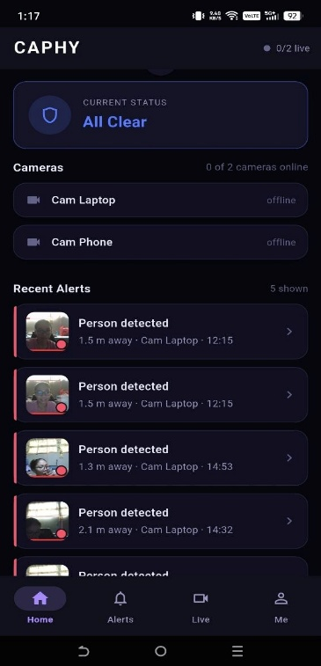
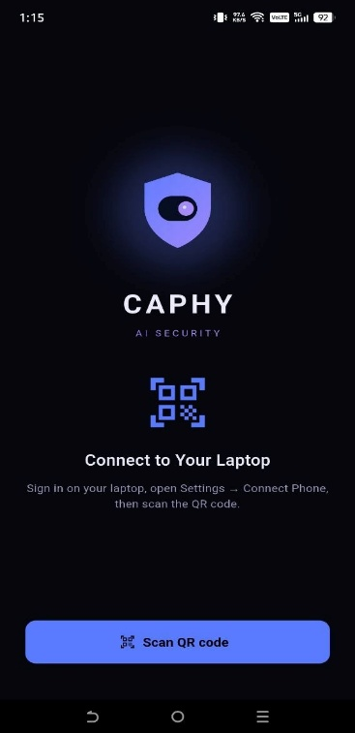
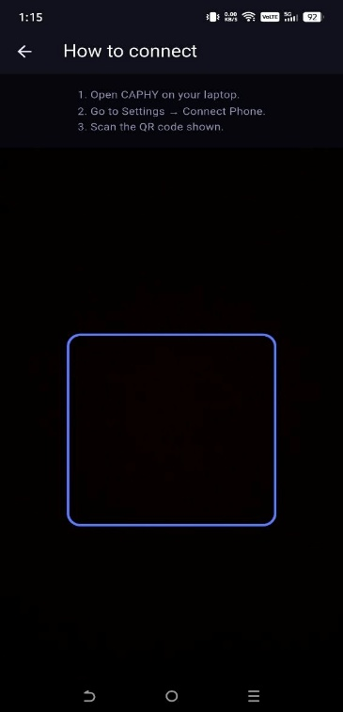
- API and Interface Specifications

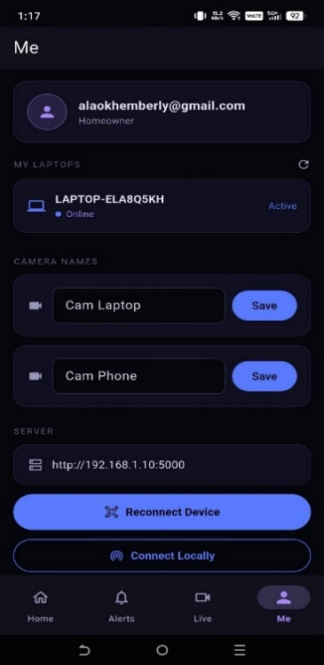
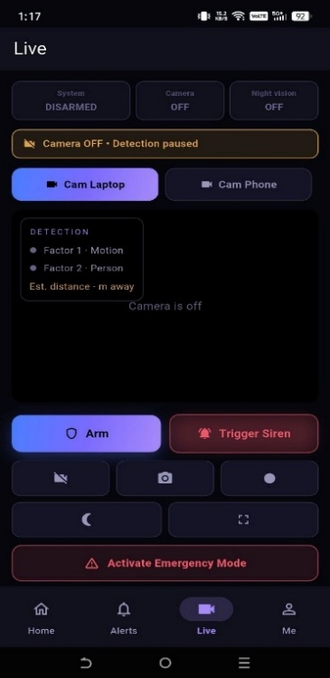
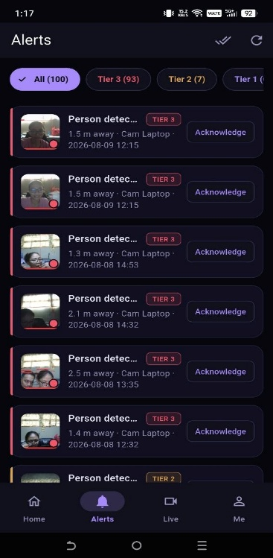



Figure 6. CAPHY App (Flutter with Firebase Cloud Messaging)
Figure 6 illustrates the CAPHY App, a custom-built mobile application developed with Flutter that serves as the primary remote-monitoring channel. The app shares the same modern dark-navy security theme as the web dashboard for a consistent experience across devices. When the host is online, the system pushes an immediate warning with a compressed image snapshot to the user’s mobile device through Firebase Cloud Messaging whenever a threat is validated, following the Three-Tier response, and follows with a video clip when the tier calls for it and bandwidth allows. Because the app is developed and maintained by the researchers rather than a third-party consumer messaging provider, alerts are delivered through CAPHY’s own application and media is kept in Firebase Storage under the owner’s account. Within the local network, the app can also open the live MJPEG camera view served by the Flask backend, for each camera independently.


Figure 7. Vosk API
Figure 7 details the Vosk API (locally hosted), which handles the system’s acoustic processing. It performs Tagalog/English speech-to-text recognition on the host machine for the system’s core command set, allowing the homeowner to change the security state (for example, disarming the alarm) without routing voice data through external cloud services such as Google Assistant or Alexa. This keeps private voice data on the local device and keeps core voice control usable during internet outages.

- Project Design
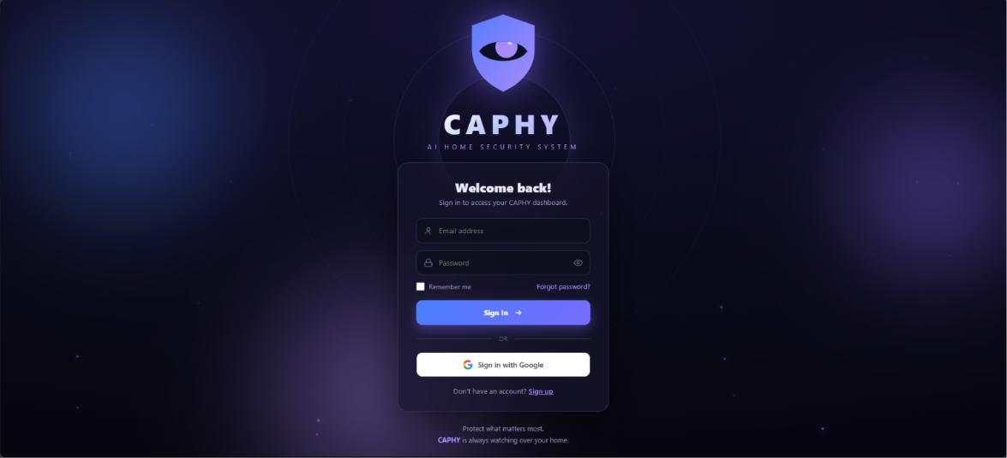

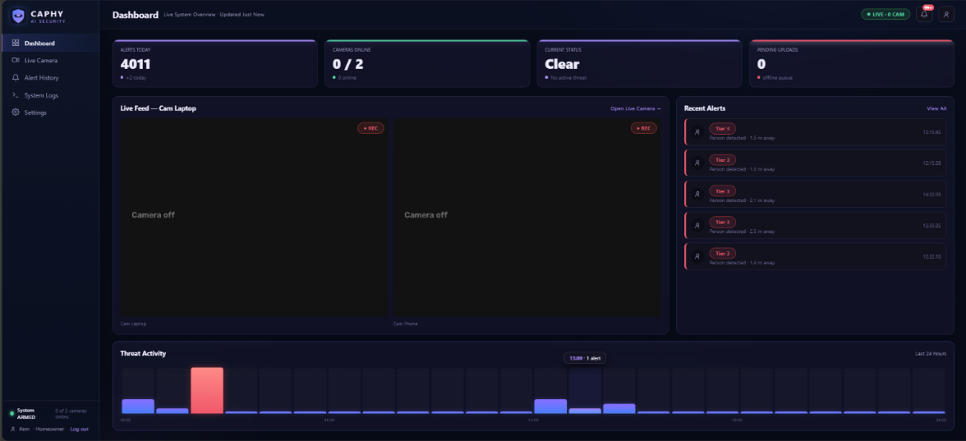

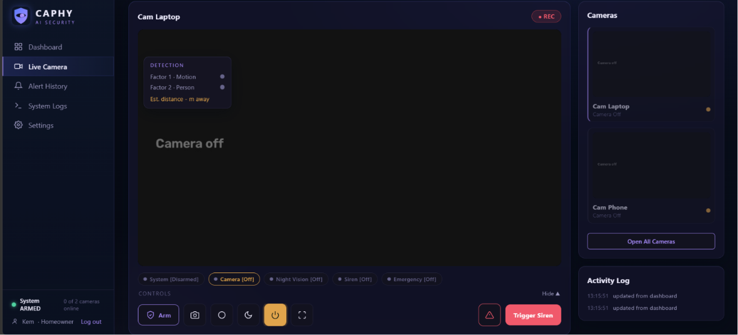

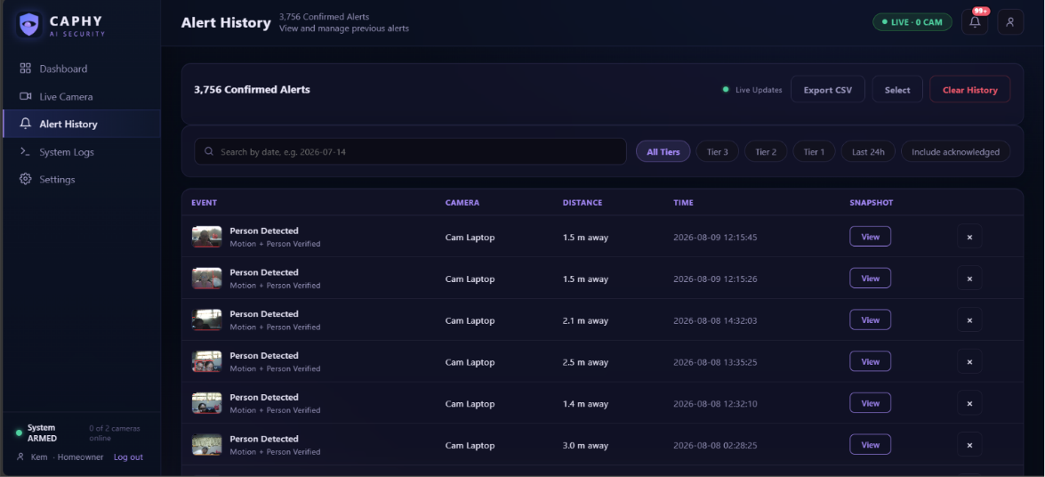

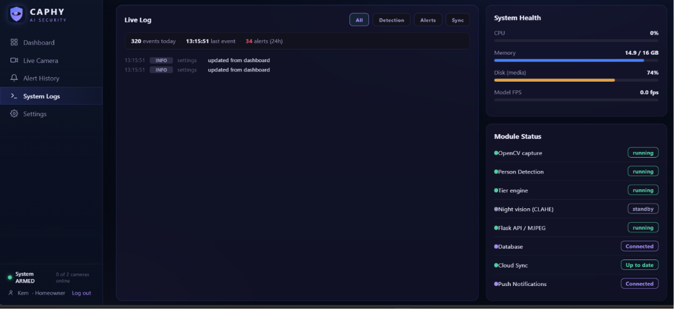

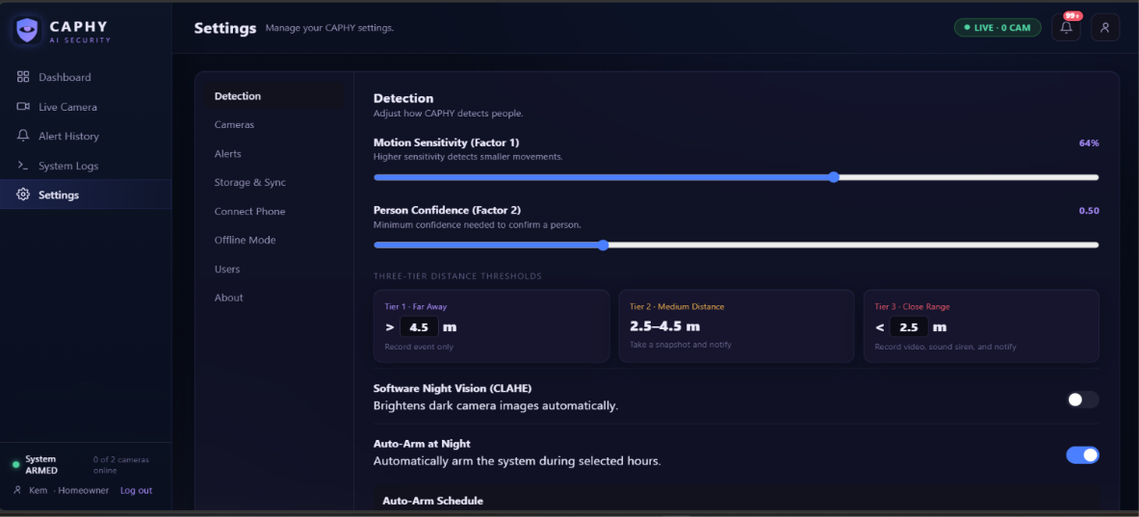

For the system-design phase, the researchers will use HTML and CSS to construct the front-end interface of the local dashboard, served by the Flask backend, while the mobile companion interface is built with Flutter. To ensure engagement and visual clarity, a deliberate, minimalist color palette will be implemented, suited to the system’s edge-lit, dark-mode aesthetic: a dark-navy background, slate-blue cards with subtle glass morphism, electric-blue accents, and teal highlights. The user interface will be mapped out prior to full development to provide an intuitive experience and mitigate usability errors. By the end of this phase, the researchers will have established a comprehensive blueprint of the system’s features and internal front-end structure.

Diagrams
To visualize the system’s infrastructure and data handling, the following diagrams will be developed:

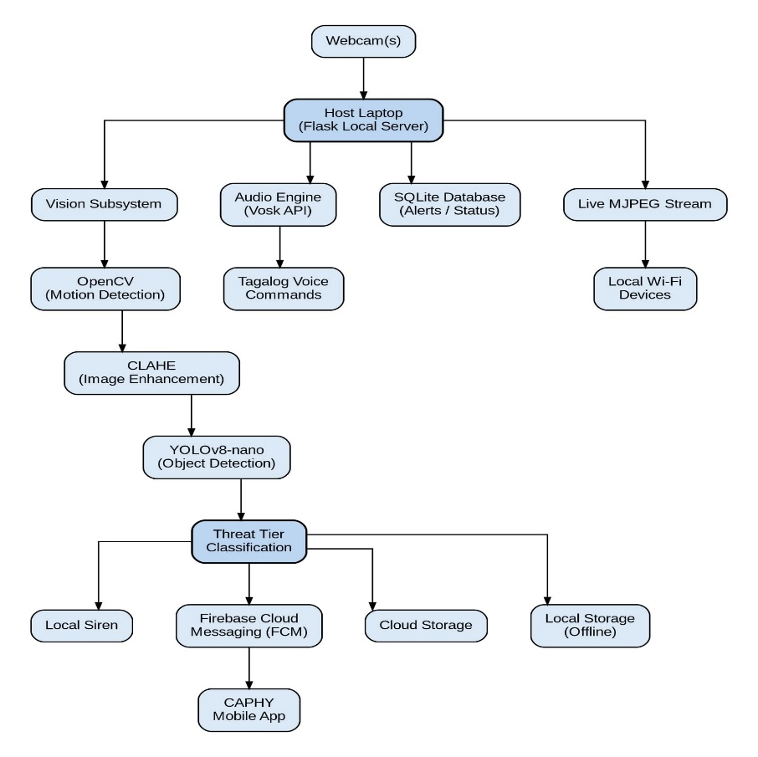
- System Architecture

Figure 8. System Architecture
Figure 8 illustrates CAPHY’s localized processing architecture. Hardware inputs (two independently controlled cameras and a microphone) feed directly into the host laptop, where a Flask-based local server coordinates the subsystems. Inside, the vision subsystem uses OpenCV for initial motion detection and CLAHE low-light enhancement, waking YOLOv8-nano only for human validation and proximity-based tier classification stabilized by distance smoothing and hysteresis. Concurrently, the audio subsystem processes Tagalog commands via the Vosk API. Validated threats trigger the local siren and dispatch tiered alerts through Firebase Cloud Messaging to the CAPHY App, while captured evidence is synced to Firebase (Firestore and Storage) when online and stored locally in compressed form when offline. Live viewing is served as an MJPEG stream on the local network per camera, and voice commands manage arming, disarming, and siren acknowledgment. This structure provides resilient, locally-processed security with hybrid storage.

- Data Flow Diagram — Context Level 0
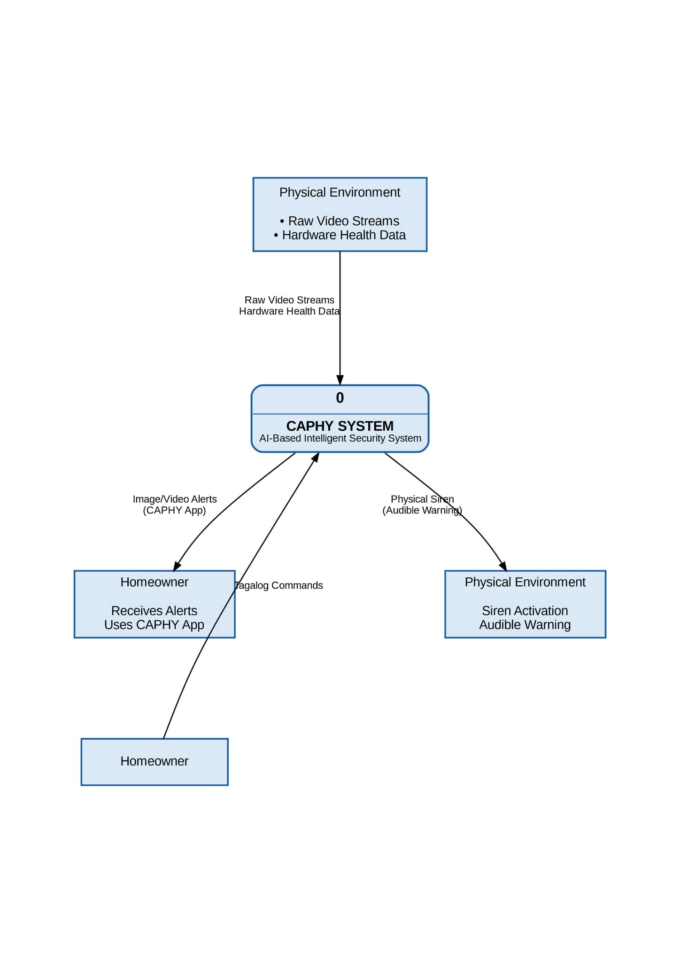

Figure 9. Data Flow Diagram (Context Level 0)
Figure 9 illustrates the Context Level 0 Data Flow Diagram, establishing the boundaries of the CAPHY system. The central security core receives “Raw Video Streams” and “Hardware Health Data” from the physical environment, alongside “Tagalog Commands” from the homeowner. Upon processing, the system outputs a “Physical Siren” signal back to the environment and dispatches “CAPHY App Image/Video Alerts” to the homeowner. This high-level model demonstrates CAPHY’s data loop, in which video processing remains localized while alerts and evidence follow the hybrid storage path.

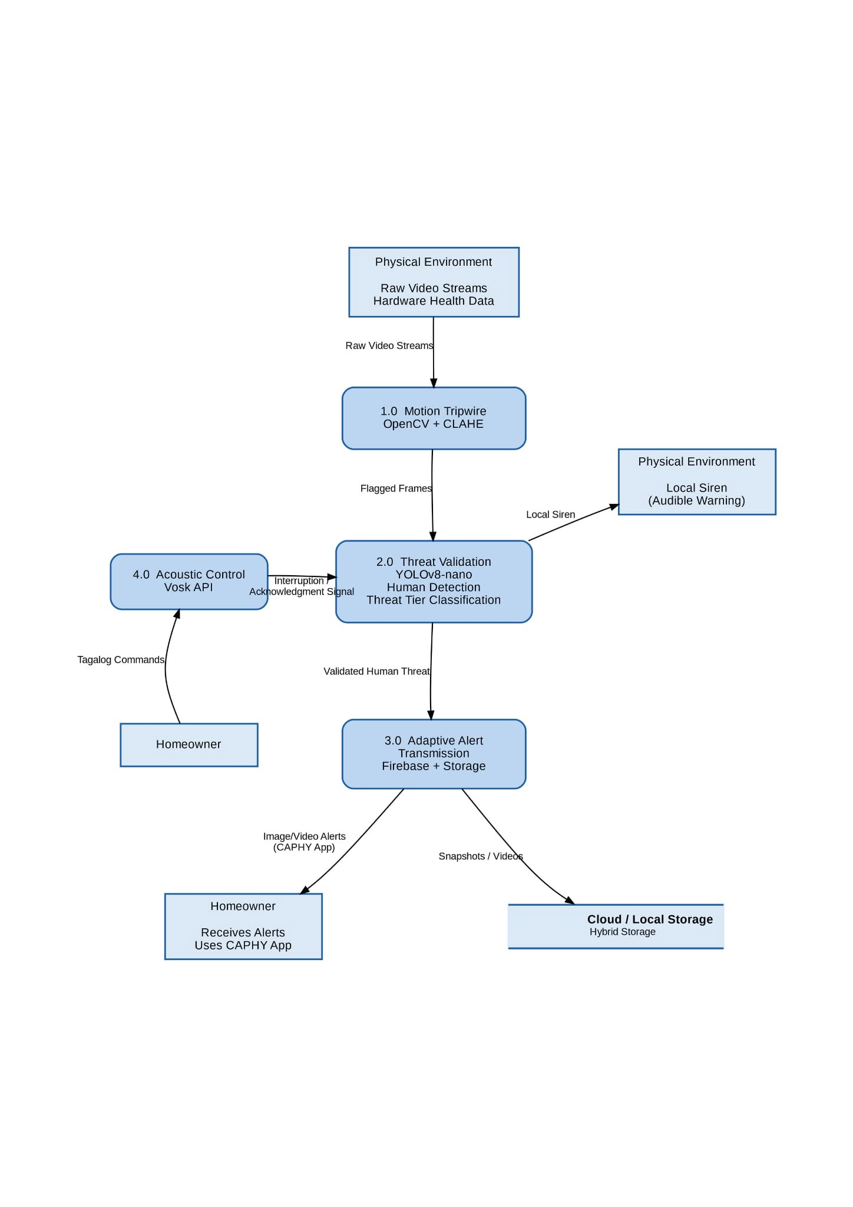
Data Flow Diagram — Context Level 1

Figure 10. Data Flow Diagram (Context Level 1)

Figure 10 details the Context Level 1 Data Flow Diagram, decomposing CAPHY’s central core into four sub-processes. “Raw Video Streams” enter Process 1.0 (Motion Tripwire – OpenCV), which passes only “Flagged Frames” to Process 2.0 (Threat Validation – YOLOv8-nano). Upon confirming a human shape and its proximity tier, Process 2.0 can trigger the local siren and forwards the “Validated Human Threat” to Process 3.0 (Adaptive Alert Transmission), which dispatches “CAPHY App Image/Video Alerts” through Firebase Cloud Messaging according to the Three-Tier response and current network condition, syncing to Firebase or compressed local storage. Concurrently, Process 4.0 (Acoustic Control – Vosk API) handles “Tagalog Commands,” sending an “Interruption/Acknowledgment Signal” back to Process 2.0 to arm, disarm, or silence the siren.

- Proposed Flowchart
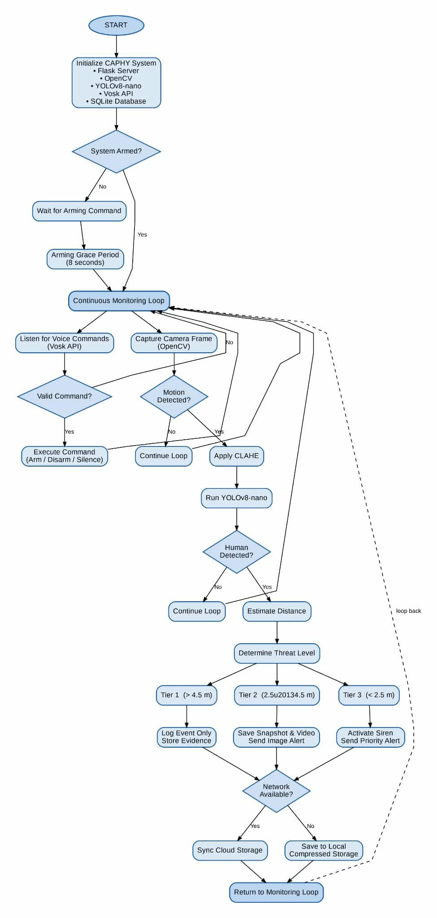

Figure 11. Flowchart
Figure 11 illustrates the logical flowchart of the CAPHY system. Operating on a continuous loop, the core engine monitors audio and visual inputs simultaneously. On the audio path, the Vosk API processes offline voice commands to arm or disarm the system and to acknowledge an active siren. On the vision path, the system executes Two-Factor Motion Validation: OpenCV serves as the initial motion tripwire (with CLAHE enhancement applied in low light), which only triggers YOLOv8-nano when the motion threshold is broken. If YOLO confirms a human presence, the system classifies the threat by proximity tier and responds accordingly — a snapshot and notification beyond 4.5 meters, adding a video clip between 2.5 and 4.5 meters, and adding the siren within 2.5 meters — before returning to its monitoring loop. When the system is in Armed mode, any confirmed detection is routed directly to the full Tier 3 response regardless of distance. A short arming grace period suppresses the siren immediately after arming, and a brief camera warm-up period after startup suppresses detection output until the feed has stabilized, so the user is not alarmed by their own presence or by a settling camera.

- Unified Modeling Language (UML) Use Case
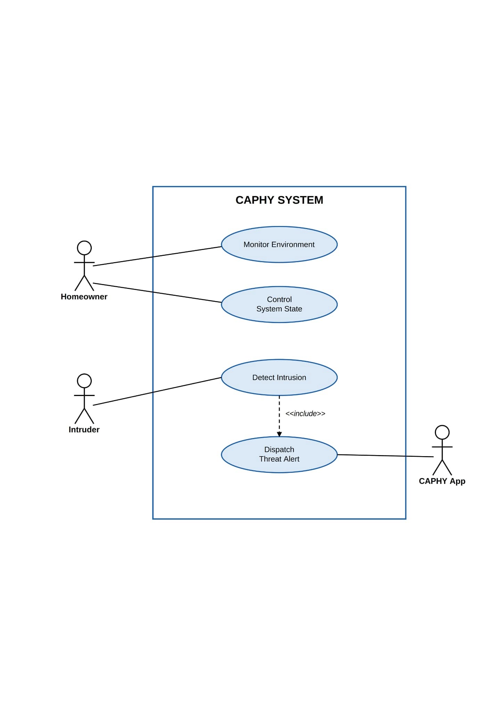

Figure 12. UML Diagram (Use Case)
Figure 12 illustrates the UML Use Case Diagram, defining the system’s functional requirements through the interactions of three primary actors: the Homeowner, the Intruder, and the CAPHY App. The Homeowner acts as the authorized user to “Monitor Environment” and “Control System State.” The Intruder serves as the external catalyst for the “Detect Intrusion” use case. A critical dependency exists between “Detect Intrusion” and “Dispatch Threat Alert,” facilitated by the CAPHY App so the Homeowner receives remote notifications. This diagram highlights the goal-oriented behavior of CAPHY from an end-user perspective.

- Database Structure
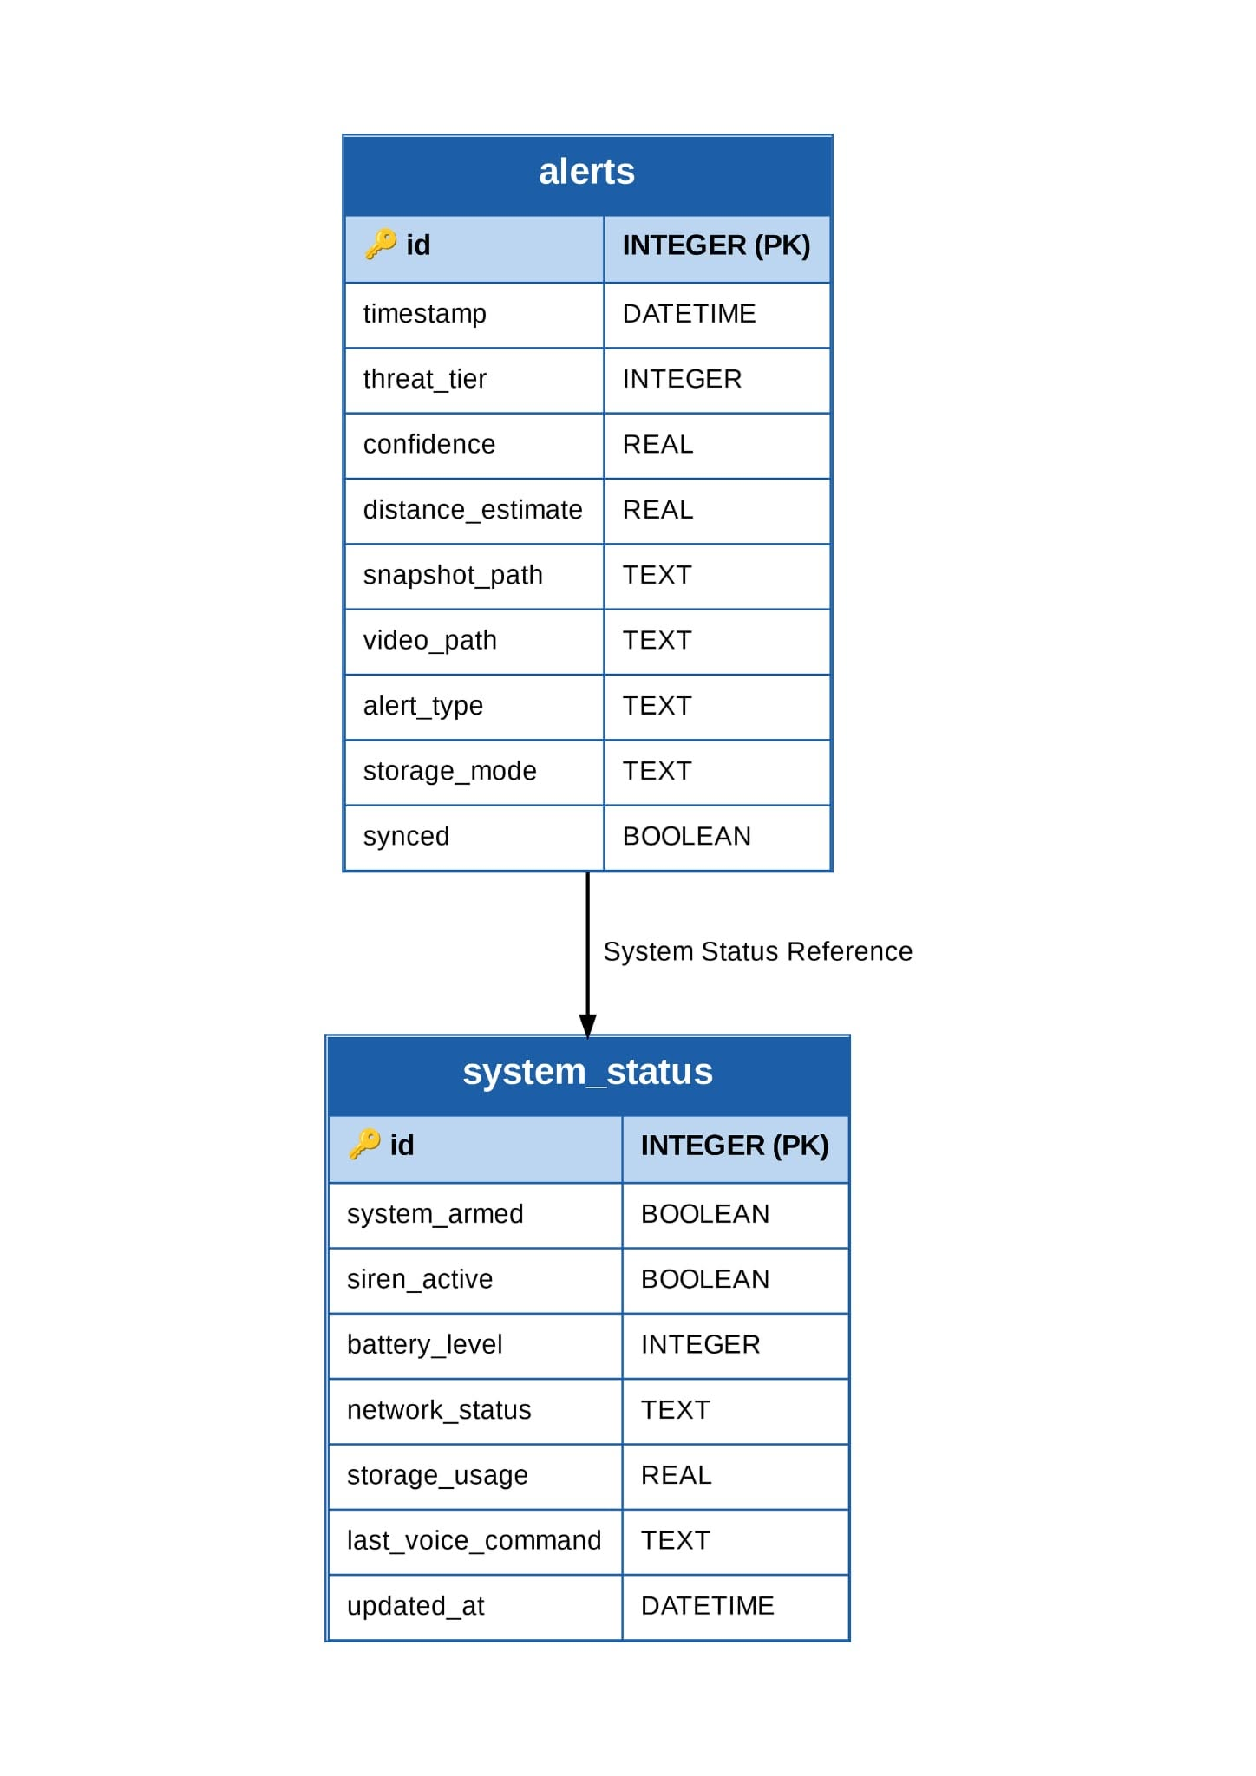

Figure 13. Database Structure
Figure 13 illustrates the local SQLite database structure, composed of the alerts and system_status tables. It stores the security-event history, including timestamps, assigned threat tier, snapshot and video file references, and system-status entries such as arming state and battery level, ensuring that event records are preserved even during internet or power outages.

- System Development
During the development phase, the researchers will iteratively construct the CAPHY system. To ensure the prototype is fully functional and optimized for the repurposed hardware, continuous unit testing will be conducted alongside the integration of the AI models (OpenCV, YOLOv8-nano, and Vosk), the Flask backend, and the CAPHY App. The backend and its REST API contract will be finalized before the dashboard and mobile interfaces are built against it, and the voice and calibration modules will be attached last. This agile approach allows the researchers to identify anomalies, resolve false-positive triggers, calibrate the tier thresholds through real distance testing, and refine the source code prior to the final evaluation.

Algorithm Discussions
Table 3:
Comparison of System Algorithms
Algorithm | Strengths | Weaknesses
OpenCV (Frame Differencing) | Consumes minimal CPU power, keeps the heavier AI dormant to optimize resource use, and processes video streams in real time. | Sensitive to sudden lighting changes (e.g., passing shadows) and cannot differentiate object types on its own.
YOLOv8-nano | Enables accurate, data-driven human detection and substantially reduces false-positive alerts and alert fatigue. | Generates significant computational load and heat if left running continuously without a primary motion trigger.
Vosk API | Performs voice recognition on-device for core commands, keeping voice data local and adapting to Tagalog speech. | Depends on clear acoustic input and lacks fluid, conversational interaction.

To fully understand the role of these algorithms within the localized architecture, their features, functions, and uses are detailed below:
- OpenCV (Open-Source Computer Vision Library)
Features: OpenCV is a lightweight, open-source computer-vision library. In this system it uses a frame-differencing feature that calculates pixel changes between consecutive frames to detect movement, and applies CLAHE (Contrast Limited Adaptive Histogram Equalization) low-light enhancement to keep the feed usable in dim conditions. Function: It functions as the system’s Level 1 motion tripwire and primary power gatekeeper. Because it requires very little CPU power, it is the only vision algorithm that runs continuously in the background. Uses: It monitors the environment for initial movement. Its primary use is to prevent the laptop from overheating (thermal throttling) by keeping the heavier YOLO model dormant until OpenCV confirms that physical motion has actually occurred.

- YOLOv8-nano (You Only Look Once, Version 8)
Features: YOLOv8-nano is a real-time object-detection model. The “nano” architecture is used because it is optimized for local processing, meaning it can run on a repurposed laptop CPU without an external GPU or cloud servers. Function: It functions as the Level 2 threat validator. Once awakened by OpenCV, it scans the flagged frames to classify the object, drawing bounding boxes and computing confidence scores for human silhouettes, and uses the bounding-box height as a proximity proxy for the 3-Tier Threat Level, with smoothing and hysteresis to keep the tier steady. Uses: It is used to reduce alert fatigue. By filtering out non-human motion (such as swaying trees, pets, or shadows), YOLOv8-nano ensures that the local siren and CAPHY App alerts are triggered only when a legitimate human presence is validated.

- Vosk API
Features: Vosk is a continuous speech-recognition toolkit that features offline acoustic modeling. It includes a Tagalog-capable language model that processes speech on the local device. Function: It functions as the system’s offline-capable voice engine. It listens to microphone input and converts Tagalog/English commands into actionable text strings, using a multi-turn dialogue protocol to confirm commands before execution. Uses: It allows the homeowner to control the system — for example, disarming the alarm by saying “CAPHY, patayin ang alarm” — without routing private voice data through third-party cloud servers. This keeps voice data on the device and keeps core control usable during ISP outages or typhoons.

CHAPTER IV
RESULTS AND DISCUSSION
This chapter presents the results and discussion of the evaluation conducted for CAPHY: An AI-Based Intelligent Security System with Two-Factor Motion Validation and Monitoring Protocols. The evaluation focused on two major areas: the functional and accuracy testing of the developed system and the user evaluation based on the ISO/IEC 25010 software quality model.

4.1 Introduction
The functional testing consisted of 45 trials covering nine test scenarios designed to determine the system's ability to distinguish actual human presence from non-human movement under different conditions. The results were analyzed using accuracy, precision, recall, F1 score, and a confusion matrix. The user evaluation involved 50 valid respondents who assessed CAPHY using the eight ISO/IEC 25010 software quality characteristics: Functional Suitability, Performance Efficiency, Compatibility, Maintainability, Portability, Reliability, Usability, and Security. The responses were analyzed using the weighted mean and standard deviation based on the Four-Point Likert Scale established in Chapter III. The findings presented in this chapter are interpreted in relation to the objectives of the study and the related literature discussed in Chapter II. The results are also used to identify the strengths, limitations, and practical implications of the developed system.

4.2 Result of System Evaluation

4.2.1 Functionality
The functionality of CAPHY was evaluated through nine test scenarios representing different conditions that the system may encounter during operation. Each scenario was conducted five times, resulting in a total of 45 functional trials.
The testing focused on the system's Two-Factor Motion Validation process. In this process, OpenCV first identifies motion in the camera frame. When motion is detected, the frame is passed to YOLOv8-nano to determine whether the movement corresponds to a person. This approach is intended to reduce unnecessary processing and prevent non-human movement from immediately generating security alerts.

Table 4.1:
Functional Test Case Results
Test Case | Scenario | Ground Truth | Trials | Passed | Result
TC001 | Empty room | No Person | 5 | 5/5 | Pass
TC002 | Person enters | Person | 5 | 5/5 | Pass
TC003 | Person exits | Person | 5 | 5/5 | Pass
TC004 | Standing person | Person | 5 | 5/5 | Pass
TC005 | Walking | Person | 5 | 5/5 | Pass
TC006 | Partial body | Person | 5 | 5/5 | Pass
TC007 | Fast movement | Person | 5 | 5/5 | Pass
TC008 | Low light | Person | 5 | 0/5 | Fail
TC009 | Non-human object | No Person | 5 | 5/5 | Pass

As shown in Table 4.1, CAPHY successfully passed eight of the nine functional scenarios. The system correctly identified persons in the person-entering, person-exiting, standing, walking, partial-body, and fast-movement scenarios. It also correctly produced no alert for the empty-room and non-human-object scenarios.
The only unsuccessful scenario was TC008, or the Low Light condition, where all five trials resulted in missed detections. This indicates that the system's detection capability is affected when the available lighting becomes insufficient for reliable visual recognition. Although CAPHY uses CLAHE-based image enhancement for low-light conditions, the results show that software-based enhancement alone cannot guarantee reliable person detection in very dark environments.
The results demonstrate that the Two-Factor Motion Validation approach was effective in the tested normal and well-lit conditions. Motion alone was not sufficient to produce a confirmed human detection because the second validation stage using YOLOv8-nano was required.

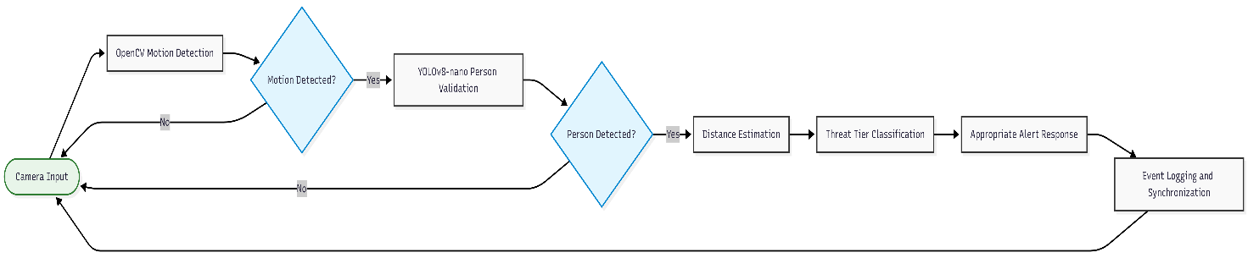

Figure 4.1. CAPHY Two-Factor Motion Validation Flowchart

4.2.2 Functional Testing Performance Metrics
The results from the 45 functional trials were further summarized using a confusion matrix and standard classification metrics.

Table 4.2
Confusion Matrix and Functional Testing Performance Metrics
Metric | Value
True Positive (TP) | 30
True Negative (TN) | 10
False Positive (FP) | 0
False Negative (FN) | 5
Accuracy | 88.9%
Precision | 100.0%
Recall | 85.7%
F1 Score | 92.3%

The system achieved an overall accuracy of 88.9%, indicating that 40 out of the 45 trials were correctly classified. The precision of 100.0% indicates that none of the alerts generated during the functional tests were false alarms. This is particularly important for CAPHY because the system was designed to address unnecessary security alerts and alert fatigue.
The recall of 85.7% indicates that the system detected most of the actual person-presence trials but missed five of them. All five missed detections occurred during the Low Light scenario. The F1 score of 92.3% reflects the combined performance of precision and recall.

The results therefore indicate that CAPHY performed particularly well in avoiding false alarms under the tested conditions. However, the lower recall demonstrates that the system's ability to detect actual persons can decrease when lighting conditions become unfavorable.

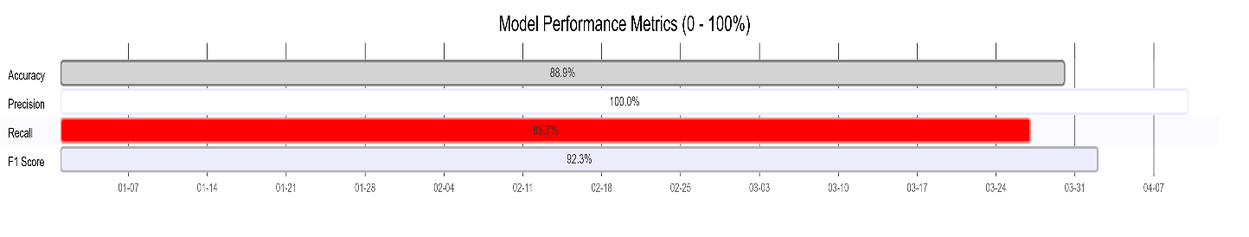

Figure 4.2. Functional Testing Performance Metrics
4.3 Performance Efficiency
Performance Efficiency was evaluated through the ISO/IEC 25010 questionnaire. This criterion covered response time, system performance, and resource utilization.

Table 4.3:
Performance Efficiency Evaluation
Item | Weighted Mean | SD | Interpretation
Response Time | 3.44 | 0.50 | Strongly Agree
System Performance | 3.42 | 0.50 | Strongly Agree
Resource Utilization | 3.44 | 0.50 | Strongly Agree
Overall | 3.43 | 0.50 | Strongly Agree

The overall weighted mean of 3.43 indicates that the respondents strongly agreed that CAPHY performs efficiently. Among the three items, Response Time and Resource Utilization received the same rating of 3.44, while System Performance received 3.42.
The result supports the feasibility of using repurposed consumer hardware for the developed system. CAPHY was designed to use a CPU-based processing approach instead of requiring a dedicated GPU. The use of OpenCV as the initial motion-detection stage also limits the need to continuously perform heavier AI inference on every frame.
However, because Performance Efficiency received a lower score than several other criteria, further optimization remains appropriate, particularly when the system is operated continuously on lower-end hardware.

4.4 Compatibility
Compatibility was evaluated in terms of hardware, application, and network compatibility.
Table 4.4:
Compatibility Evaluation
Item | Weighted Mean | SD | Interpretation
Hardware Compatibility | 3.44 | 0.50 | Strongly Agree
Application Compatibility | 3.38 | 0.49 | Strongly Agree
Network Compatibility | 3.44 | 0.50 | Strongly Agree
Overall | 3.42 | 0.50 | Strongly Agree

Compatibility obtained an overall weighted mean of 3.42, which remained within the Strongly Agree range. However, it was the lowest-scoring criterion among the eight ISO/IEC 25010 characteristics.
Application Compatibility received the lowest individual score of 3.38. This suggests that although respondents generally found CAPHY compatible with its intended applications and devices, compatibility has more room for improvement compared with the other evaluated characteristics.
The result is important for a system intended to operate using different cameras, mobile devices, computers, and network conditions. Future testing involving a wider variety of hardware and mobile devices may provide additional evidence regarding the portability and compatibility of CAPHY.

4.5 Maintainability
Maintainability was evaluated based on system organization, ease of updating, and troubleshooting.
Table 4.5:
Maintainability Evaluation
Item | Weighted Mean | SD | Interpretation
System Organization | 3.48 | 0.50 | Strongly Agree
Ease of Updating | 3.58 | 0.50 | Strongly Agree
Troubleshooting | 3.54 | 0.50 | Strongly Agree
Overall | 3.53 | 0.50 | Strongly Agree
The overall weighted mean of 3.53 indicates that respondents strongly agreed with the maintainability of CAPHY. Ease of Updating received the highest rating at 3.58, followed by Troubleshooting at 3.54.
The results suggest that the system's organization and update process were perceived positively by the respondents. The modular structure of the system, including its vision, camera, audio, alerting, storage, dashboard, and mobile application components, supports the possibility of modifying individual parts without redesigning the entire system.

4.6 Portability
Portability was evaluated through installation, operating environment, and deployment.
Table 4.6:
Portability Evaluation
Item | Weighted Mean | SD | Interpretation
Installation | 3.56 | 0.50 | Strongly Agree
Operating Environment | 3.46 | 0.50 | Strongly Agree
Deployment | 3.48 | 0.50 | Strongly Agree
Overall | 3.50 | 0.50 | Strongly Agree

Portability obtained an overall weighted mean of 3.50, indicating Strongly Agree. Installation received the highest item score of 3.56, while Operating Environment received the lowest at 3.46.
These findings indicate that respondents generally perceived CAPHY as capable of being installed and deployed in compatible environments. This supports the project's objective of using repurposed hardware instead of requiring a dedicated security appliance.
Nevertheless, the results should not be interpreted as evidence that CAPHY can operate on every computer or device. Deployment remains dependent on compatible hardware, camera availability, operating environment, and other system requirements established by the study.

4.7 Reliability
Reliability was evaluated through system stability, continuous operation, and data preservation.
Table 4.7:
Reliability Evaluation
Item | Weighted Mean | SD | Interpretation
System Stability | 3.48 | 0.50 | Strongly Agree
Continuous Operation | 3.56 | 0.50 | Strongly Agree
Data Preservation | 3.52 | 0.50 | Strongly Agree
Overall | 3.52 | 0.50 | Strongly Agree

The overall weighted mean of 3.52 indicates that respondents strongly agreed with CAPHY's reliability. Continuous Operation received the highest rating of 3.56, while System Stability received the lowest rating of 3.48.
The result supports the system's hybrid local and cloud-oriented design. CAPHY maintains local event information through SQLite while synchronization with Firebase is performed when connectivity is available. This design allows the system to continue retaining local records even when cloud connectivity is unavailable.
The result should be interpreted as favorable user evaluation rather than proof of complete operational reliability under every possible failure condition. Extended testing involving longer operating periods and additional hardware conditions may further validate the system's reliability.

4.8 Usability
Usability was evaluated through ease of use, interface navigation, and alerts and feedback.
Table 4.8:
Usability Evaluation
Item | Weighted Mean | SD | Interpretation
Ease of Use | 3.48 | 0.50 | Strongly Agree
Interface Navigation | 3.40 | 0.49 | Strongly Agree
Alerts and Feedback | 3.54 | 0.50 | Strongly Agree
Overall | 3.47 | 0.50 | Strongly Agree
The overall weighted mean of 3.47 indicates that respondents strongly agreed with the usability of CAPHY. Alerts and Feedback received the highest rating at 3.54, indicating positive perception of the system's alert and feedback mechanisms.
Interface Navigation received the lowest score within this criterion at 3.40. Although it remained within the Strongly Agree range, the result indicates that navigation may be an area for further interface improvement, particularly for first-time users.
The findings support the objective of providing both a mobile application and browser-based dashboard for monitoring and controlling the security system.

4.9 Security
Security was evaluated through data protection, secure communication, and user confidence.
Table 4.9:
Security Evaluation
Item | Weighted Mean | SD | Interpretation
Data Protection | 3.54 | 0.50 | Strongly Agree
Secure Communication | 3.52 | 0.50 | Strongly Agree
User Confidence | 3.58 | 0.50 | Strongly Agree
Overall | 3.55 | 0.50 | Strongly Agree

Security received an overall weighted mean of 3.55, placing it in the Strongly Agree range and tying Functional Suitability as the highest-rated ISO/IEC 25010 criterion.
User Confidence received the highest individual rating at 3.58. Data Protection received 3.54, while Secure Communication received 3.52.
The results indicate that respondents perceived CAPHY's security-related functions favorably. However, the survey measures user perception and should not be interpreted as a complete technical security audit. Additional penetration testing, vulnerability assessment, and security testing would be necessary to establish broader security assurance.

4.10 Summary of the Respondents' Evaluation Criteria
The following table summarizes the results of the 50-respondent ISO/IEC 25010 evaluation.
Table 4.10:
Summary of ISO/IEC 25010 Evaluation Results (n = 50)
Criterion | Weighted Mean | SD | Interpretation
Functional Suitability | 3.55 | 0.50 | Strongly Agree
Performance Efficiency | 3.43 | 0.50 | Strongly Agree
Compatibility | 3.42 | 0.50 | Strongly Agree
Maintainability | 3.53 | 0.50 | Strongly Agree
Portability | 3.50 | 0.50 | Strongly Agree
Reliability | 3.52 | 0.50 | Strongly Agree
Usability | 3.47 | 0.50 | Strongly Agree
Security | 3.55 | 0.50 | Strongly Agree
Overall | 3.50 | 0.50 | Strongly Agree

The overall weighted mean of 3.50 indicates that the respondents strongly agreed with the evaluated qualities of CAPHY. Functional Suitability and Security obtained the highest category-level ratings at 3.55, while Compatibility obtained the lowest at 3.42. Despite this difference, all eight criteria remained within the Strongly Agree interpretation range.
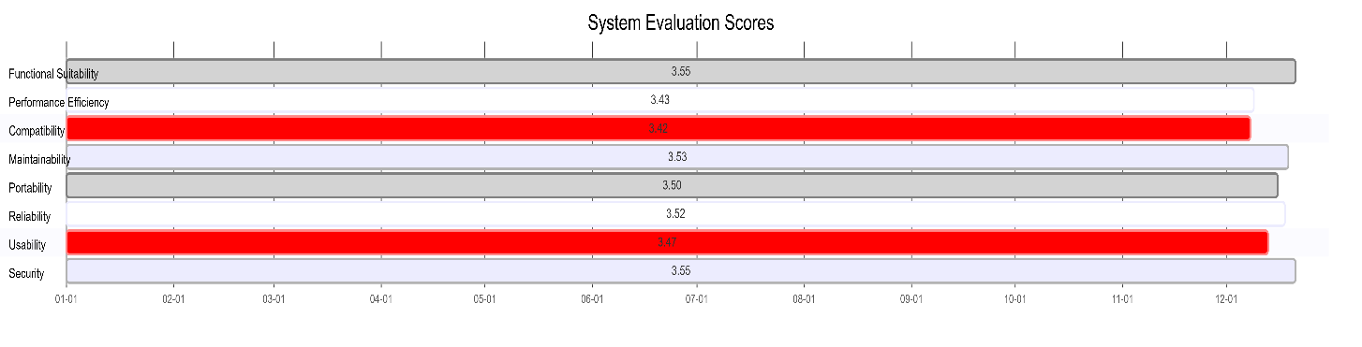

Figure 4.3. Summary of ISO/IEC 25010 Evaluation Results

4.11 Respondent Profile
The evaluation included 50 valid respondents.
Table 4.11:
Respondent Distribution (n = 50)
Respondent Category | Frequency | Percentage
Homeowners | 45 | 90%
Computer Laboratory Personnel | 5 | 10%
Total | 50 | 100%
The respondents were composed of 45 homeowners and five computer laboratory personnel. Homeowners represented the majority of the respondents, reflecting the household-oriented purpose of CAPHY. The computer laboratory personnel provided a smaller technical perspective regarding the system.
The distribution should be considered when interpreting the results, particularly for technical characteristics such as Performance Efficiency, Compatibility, Maintainability, and Portability.

4.12 Discussion of Results
The results demonstrate that CAPHY achieved favorable outcomes in both objective functional testing and subjective user evaluation.
The functional testing provides direct evidence of the behavior of the Two-Factor Motion Validation process. Across 45 trials, the system achieved 100% precision, with no false positives recorded. The empty-room and non-human-object scenarios both achieved five successful trials out of five. This finding supports the purpose of using a motion-detection stage before human-object validation because movement alone was not automatically treated as a confirmed security threat.
This result is consistent with the reviewed literature concerning alert fatigue. Systems that produce unnecessary alerts may reduce user attention to actual threats. CAPHY's two-stage validation approach addresses this concern by requiring both motion and human confirmation before a person is treated as a confirmed detection.
However, the functional testing also identified a clear limitation. All five Low Light trials resulted in false negatives. The finding demonstrates that CLAHE-based enhancement can assist with low-light visibility but cannot fully replace dedicated infrared or other hardware designed for extremely dark environments. The reduction in recall from this condition is therefore an important limitation of the current prototype.
The ISO/IEC 25010 evaluation also produced favorable results. All eight software quality characteristics obtained interpretations of Strongly Agree. Functional Suitability and Security were the highest-rated criteria, both receiving a weighted mean of 3.55. These results indicate that respondents generally perceived CAPHY as capable of performing its intended functions and providing acceptable security-related features.
Compatibility received the lowest overall weighted mean at 3.42. Although this remains within the Strongly Agree range, it suggests that compatibility is a relative area for improvement. Application Compatibility, with a weighted mean of 3.38, was the lowest individual item in the questionnaire.
Performance Efficiency also received a comparatively lower rating of 3.43. This finding is relevant to CAPHY's use of repurposed CPU-only hardware. The system demonstrates that the proposed architecture is viable within the tested environment, but further optimization may be necessary for lower-end hardware or longer periods of continuous operation.
Overall, the findings support the study's central proposition that a security system using local processing, Two-Factor Motion Validation, and adaptive monitoring can be implemented using repurposed hardware. At the same time, the results show that the system should not be considered completely free from limitations, particularly under very low-light conditions.

4.13 Implications of the Findings
The findings have several practical implications for the intended use of CAPHY.
First, the zero false positives recorded during functional testing indicate that the Two-Factor Motion Validation approach has potential to reduce unnecessary security alerts under the tested conditions. This is important for households where frequent false alarms may cause users to ignore future notifications.
Second, the favorable Performance Efficiency and Reliability ratings support the feasibility of using repurposed laptops as local processing devices. This approach may reduce the need for specialized security hardware while allowing the system to perform its core detection functions locally.
Third, the favorable Compatibility, Usability, and Portability results indicate that respondents generally accepted the use of the system through its intended interfaces and deployment environment. However, the relatively lower Compatibility rating shows that broader device and network testing would be beneficial.
Fourth, the low-light failure has a direct implication for deployment. CAPHY should not be relied upon as a complete replacement for infrared-equipped security systems in environments that may become completely dark. Additional lighting or infrared hardware should be considered for future versions.
Finally, the overall ISO/IEC 25010 result of 3.50, interpreted as Strongly Agree, indicates favorable user acceptance across all eight evaluated software quality characteristics. However, this result represents the perception of the respondents and should be considered together with the objective functional testing results.

4.14 Chapter Summary
This chapter presented the results and discussion of CAPHY's functional testing and ISO/IEC 25010 evaluation.
The functional testing involved 45 trials across nine scenarios and resulted in 88.9% accuracy, 100.0% precision, 85.7% recall, and 92.3% F1 score. No false positives were recorded, while all five false negatives came from the Low Light scenario.
The ISO/IEC 25010 evaluation involved 50 respondents and produced an overall weighted mean of 3.50, interpreted as Strongly Agree. All eight software quality characteristics achieved the Strongly Agree interpretation, with Functional Suitability and Security receiving the highest category-level scores of 3.55 and Compatibility receiving the lowest at 3.42.
The findings indicate that CAPHY successfully demonstrated its core detection and monitoring functions within the tested conditions while also identifying areas requiring further improvement. The conclusions and recommendations based on these findings are presented in Chapter V.

CHAPTER V

SUMMARY, CONCLUSIONS AND RECOMMENDATIONS

5.1 Summary of Findings
This study developed and evaluated CAPHY: An AI-Based Intelligent Security System with Two-Factor Motion Validation and Monitoring Protocols. The evaluation consisted of functional and accuracy testing and an ISO/IEC 25010-based user evaluation.
The functional testing involved 45 trials across nine scenarios. The system achieved an overall accuracy of 88.9%, precision of 100.0%, recall of 85.7%, and F1 score of 92.3%. The system recorded 30 true positives, 10 true negatives, zero false positives, and five false negatives. The five false negatives all occurred during the Low Light scenario. The results show that CAPHY was effective in avoiding false alarms during the tested normal and well-lit conditions, while detection reliability decreased under insufficient lighting.
The user evaluation involved 50 valid respondents, consisting of 45 homeowners and five computer laboratory personnel. The evaluation used the eight ISO/IEC 25010 software quality characteristics. The overall weighted mean was 3.50 with a standard deviation of 0.50, interpreted as Strongly Agree.
Functional Suitability obtained a weighted mean of 3.55, Performance Efficiency obtained 3.43, Compatibility obtained 3.42, Maintainability obtained 3.53, Portability obtained 3.50, Reliability obtained 3.52, Usability obtained 3.47, and Security obtained 3.55. All eight criteria were interpreted as Strongly Agree.
Functional Suitability and Security were the highest-rated criteria, while Compatibility was the lowest-rated criterion. Application Compatibility, with a weighted mean of 3.38, was the lowest individual item among the 24 evaluation items.
The findings therefore show that CAPHY received favorable evaluations across all eight software quality characteristics while also demonstrating strong precision during objective functional testing. At the same time, the low-light condition represents a confirmed technical limitation of the current prototype.

5.2 Conclusions
Based on the findings of the study, the following conclusions were drawn.
First, the study concludes that the Two-Factor Motion Validation approach was effective under the tested normal and well-lit conditions. The system achieved 100% precision and recorded zero false positives across 45 functional trials. This indicates that requiring motion detection followed by human-object validation can effectively prevent the tested non-human movements from being treated as confirmed human threats.
Second, the study concludes that the repurposed hardware architecture is feasible for the developed prototype. The favorable Performance Efficiency, Reliability, and Portability evaluations indicate that respondents generally accepted the system's operation using compatible consumer hardware. However, the study does not establish that every available computer can support CAPHY because performance remains dependent on the hardware configuration and operating environment.
Third, the study concludes that the CAPHY monitoring and alerting functions were favorably received by the respondents. The Usability criterion received a weighted mean of 3.47, while Alerts and Feedback received an individual rating of 3.54. These results indicate that respondents generally found the system's monitoring interfaces and feedback mechanisms acceptable.
Fourth, the study concludes that CAPHY achieved favorable overall software quality evaluation according to ISO/IEC 25010. All eight characteristics were rated Strongly Agree, with an overall weighted mean of 3.50. This indicates a high level of user acceptance of the developed prototype across functionality, performance, compatibility, maintainability, portability, reliability, usability, and security.
Fifth, the study concludes that CAPHY has a significant low-light limitation. The five false negatives recorded during the functional testing all occurred in the Low Light scenario. Therefore, although CLAHE-based image enhancement can support visibility in dim conditions, the current implementation cannot guarantee reliable person detection in very dark environments.
Finally, the study concludes that CAPHY met its primary development and evaluation objectives within the scope of the prototype and testing conditions. The
results provide evidence that a locally processed security system using Two-Factor Motion Validation and repurposed hardware can be implemented and favorably evaluated. However, the system should be considered a prototype with specific limitations rather than a complete replacement for all commercial security systems.

5.3 Recommendations
Based on the findings and limitations of the study, the following recommendations are proposed.

5.3.1 Improve Low-Light Detection
Future versions of CAPHY should improve detection performance under low-light conditions. Additional infrared hardware, supplemental lighting, or another suitable camera technology may be considered. The CLAHE enhancement process may also be further optimized, and additional low-light training and testing data may be used to improve the performance of the detection model.

5.3.2 Improve Compatibility
Since Compatibility received the lowest ISO/IEC 25010 category rating of 3.42, future development should focus on testing CAPHY with a wider range of cameras, mobile devices, computers, and network configurations. This would help determine whether the current system can maintain consistent behavior across a broader range of supported hardware and environments.

5.3.3 Optimize Performance Efficiency
Further optimization of the detection pipeline is recommended, particularly for lower-end repurposed laptops. Future testing may examine longer continuous operation and different hardware configurations to determine how processing performance changes under sustained workloads.

5.3.4 Expand Functional Testing
Future studies should conduct more functional trials and include additional environmental conditions. Testing may include different room sizes, camera positions, lighting levels, movement speeds, partial occlusion, multiple persons, and other realistic household conditions. A larger number of trials would provide stronger evidence regarding the general performance of the detection system.

5.3.5 Expand Technical Evaluation
Future evaluations should include a larger number of technical evaluators in addition to homeowners. The current study included five computer laboratory personnel out of 50 respondents. Increasing the technical-evaluator representation may provide more detailed feedback regarding Performance Efficiency, Compatibility, Maintainability, Portability, and Security.

5.3.6 Improve Qualitative Feedback Collection
Future researchers should consider using structured interviews or guided feedback sessions alongside the quantitative ISO/IEC 25010 questionnaire. The open-ended questions in the current survey did not produce sufficient detailed responses to establish meaningful qualitative themes. Guided questions may provide more useful information regarding user difficulties, preferred features, and recommended improvements.

5.3.7 Continue Development of Offline and Hybrid Monitoring
Future development may further improve CAPHY's local and hybrid monitoring capabilities. The system's ability to maintain local operation and synchronize information when connectivity becomes available should continue to be tested under different network and connectivity conditions.

5.3.8 Conduct Additional Security Testing
Although Security received a favorable weighted mean of 3.55, the survey represents user perception rather than a complete technical security assessment. Future studies should conduct dedicated security testing, such as vulnerability assessment and controlled penetration testing, to provide stronger evidence regarding the security of the application, communication channels, authentication mechanisms, and stored data.

5.4 Final Statement
CAPHY demonstrated favorable results as a prototype intelligent security system that combines local processing, Two-Factor Motion Validation, and adaptive monitoring. The system achieved zero false positives during the conducted functional trials and received a Strongly Agree overall evaluation from the 50 respondents based on ISO/IEC 25010.
At the same time, the study identified low-light detection as a clear technical limitation and Compatibility and Performance Efficiency as areas with greater room for improvement. These findings provide a practical basis for future enhancements and further testing. Within the defined scope and testing conditions, the study demonstrates that the proposed CAPHY approach is feasible and has potential for further development as a locally oriented security monitoring system.

